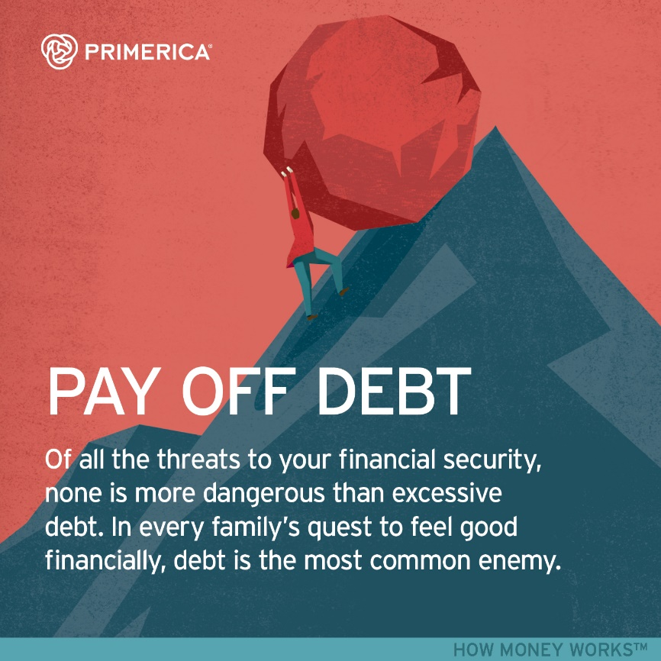
GET OUT OF DEBT NOW
A financial webinar
Friday 7-8 pm on Zoom:
ID: 629 673 3497
Passcode: winners
